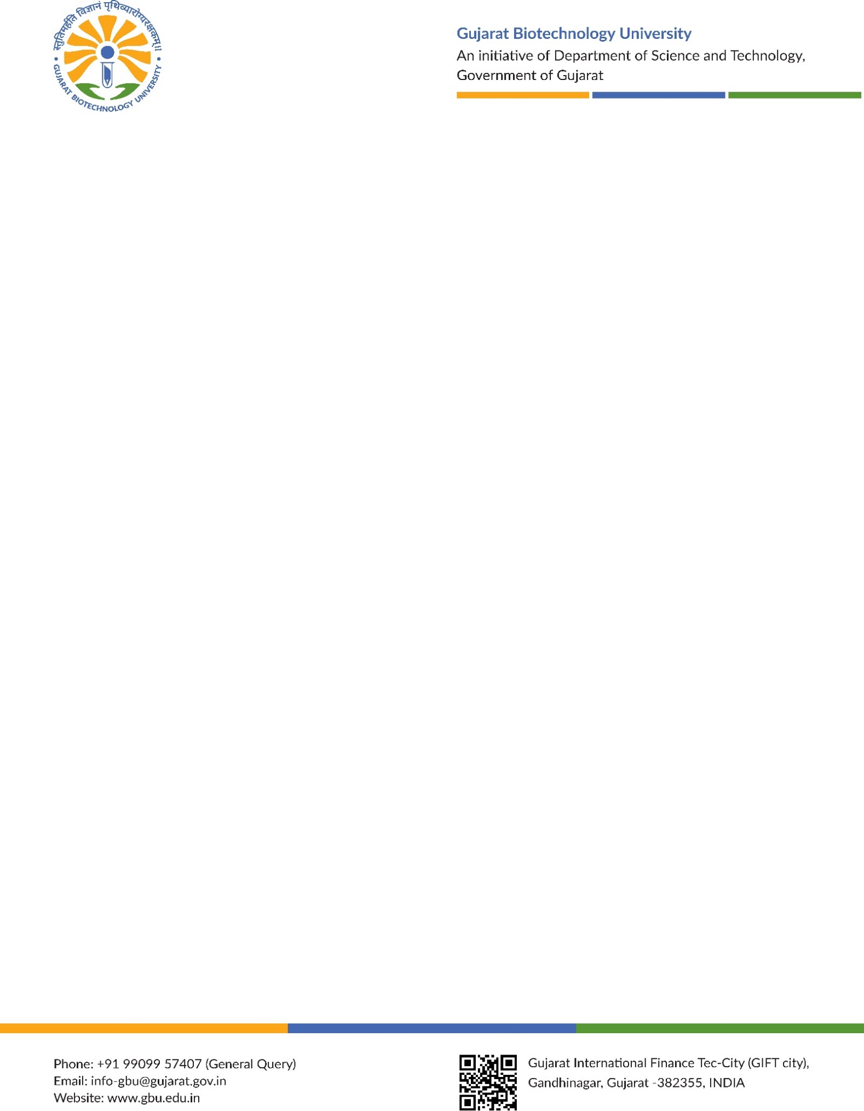 | GUJARAT BIOTECHNOLOGY UNIVERSITY  Gujarat International Finance Tec (GIFT)-City,  Shahpur village, Gandhinagar- 382355, Gujarat, India
ADVERTISEMENT NO. GBU/EST/PwD/01/2025
Special Recruitment Drive for Person with Disability (PwD) candidate

Gujarat Biotechnology University (GBU) is a new post graduate university established by the Gujarat Biotechnology University Act 2018. In a unique collaboration with world-leading University of Edinburgh, GBU will place excellence and innovation at its core to deliver biotechnology solutions for society’s needs. GBU invites applications from exceptional scholars as founding faculty for the roles below. We especially encourage applications from candidates whose research is translational and has high potential of product, process or prototype development.
Sr. No. | Discipline | Position | Total Post(s) (No.) | Blindness and low vision | Deaf and hard of hearing | Movement disorders including cerebral palsy, deviance, those recovering from blood poisoning, dwarfism, acid attack victims and weak muscles | Autism, intellectual disability, specific learning disability and mental illness - D and more than one type of disability from the person under A and D - E
 |  |  |  | A (1%) | B (1%) | C (1%) | D & E (1%)
 | Medical Biotechnology | Associate Professor | 01 | B, LV | D, HH | OA, BA, OL, BL, OAL, LC, Dw, AAV, SD, SI | ASD (M), SLD, MI MD Involving (a) to (d) above
2. | Management and Entrepreneurship | Assistant Professor | 01 | B, LV | D, HH | OA, BA, OL, BL, OAL, LC, Dw, AAV, SD, SI | ASD (M), SLD, MI MD Involving (a) to (d) above

The Other terms, conditions, educational qualifications, experience criteria and application form are available at https://www.gbu.edu.in Indian citizens and persons with Overseas Citizen of India (OCI) status shall be eligible for appointment with prior necessary clearances from Ministry of Home Affairs (MHA) and Ministry of External Affairs (MEA) or any authority as specified by Government of India from time to time.
Last date for receiving online applications is 02/10/2025 (23:59 hrs). The candidate sends Hardcopy of filled application along with all necessary documents (copies of certificates, experience etc.) to GBU by 07/10/2025.
Date:12/09/2025 | Sd/-  Registrar  Gujarat Biotechnology University

Disability Abbreviation (B=Blind, LV=Low Vision, HH=Hard of Hearing, OA=One Arm, OL=One Leg, OAL/OLA=One Arm & One Leg, BL=Both Leg, BLOA=Both Legs & One Arm, CP=Cerebral Palsy, LC=Leprosy Cured, Dw=Dwarfism, AAV=Acid Attack Victims, SLD=Specific Learning Disability, MI=Mental Illness, MD=Multiple Disability, MDy=Muscular Dystrophy, ASD=Autism Spectrum Disorder, D=Deaf, BA=Both Arm, DF=Spine Deformity, SI=Spine Injury, ID=Intellectual Disability, M=Mild, Mod=Moderate)
PwD Benchmark Disability is decided by Department of Science & Technology, Government of Gujarat Resolution No. DST/GBU/e-file/24/2024/0565/BT.

Important Dates :
Date of Commencement of online application : 12/09/2025 11:00 AM
Last Date of Online Application submission: 02/10/2025 23:59 PM
Last Date of physical application submission : 07/10/2025, 18:10 PM

How to apply:
Apply online through the university’s recruitment portal: www.gbu.edu.in/career/
Submit a physical copies ( one original set and two photocopies along with all self attested enclosures) of the application along with all enclosure by 07/10/2025.
Separate application is required for each post, otherwise the application form will be rejected.

Additional Information:
Detailed information regarding eligibility criteria, required documents, and other instructions can be found on the university website: https://gbu.edu.in

ADVERTISEMENT NO. GBU/EST/01/2025
RULES & REGULATIONS
Last date of online application: 02/10/2025 (Time: 23:59)

- Online application form can be filled using the portal: https://gbu.edu.in/career/. The number of posts, essential qualifications, experiences, general terms and conditions etc. can be downloaded from the University website https://gbu.edu.in/career/
- Submit three (1 Original + 2 Photocopies) hardcopies of online filled application form, with self-attested copies of certificates in support of your qualifications, experience, age, publication and all other claims made by you in a proper sequence of enclosures with numbering should reach to “THE REGISTRAR, GUJARAT BIOTECHNOLOGY UNIVERSITY, GIFT-CITY, Gandhinagar on or before 07/10/2025 up to 18:10 pm. Only online application will not be considered.
- The Last Date to submit Online Applications is 02/10/2025, 23:59 pm.
- Applicants are advised to submit the applications to the University well in advance without waiting for the last date to avoid postal delay or any delay due to other unforeseen events or circumstances. The University will not be responsible for any postal delay or any delay at any stage. Applications received after the last date and time mentioned above will be rejected.
- The candidate having necessary medical certificate of disability of 40% and above shall be considered as physically disabled.
- Persons with Disability (PwD) are required to submit the relevant Disability Certificate issued by the competent authority as per the policy of the Government of Gujarat.
- Reservation for Persons with Disabilities will be as per the existing policy of Government of Gujarat, Department of Social Justice and Empowerment and its amendments from time to time till the last date of receiving application.
- Applicants who are already in service should forward printed copy of online filled application form (hard copy) through proper channel. Direct application will not be considered. However, such a candidate can send in advance, one copy of online application form, so as to reach before the deadline. Such an application will be deemed in time, provided the hard copy of application through proper channel is forwarded before last date.
If the original application through proper channel has not been received by the University till the last date mentioned in this employment notification, the applicants will have to submit a ‘NO OBJECTION CERTIFICATE’ from his/her employer to the University at the time of interview.
- The candidates must fulfil all eligibility conditions as of the last date of receiving the application.
- The reservations/relaxations policy for SC/ST/SEBC/EWS/PwD Candidates will be provided as per the existing Govt. of Gujarat rule, and subsequent amendments from time to time till the last date of receiving application.
- S.E.B.C. candidate should furnish the "Non-Creamy-layer certificate" valid for the current financial year of their parents in the prescribed Performa along with his/her application form.
- Candidate belonging to SC/ST/SEBC/EWS/ PwD category should submit prescribed certificate as per the Performa of State Government and Norms, failing which the candidate will not be entitled to get the benefit of reserved category.
- Applicant should also submit a self-attested photocopy of any Government issued proof of Identity.
- If a Candidate holds foreign University degree, he/she shall produce an equivalence certificate Page 6 of 10 issued by AIU (Association of Indian University) at the time of application.
- A candidate who provides incorrect or false information or suppresses information will be disqualified and, if appointed, will be liable to be dismissed.
- Candidates who wish to apply for more than one post should submit separate online applications and hard copy for each of the posts with enclosures.
- No application fee is to be paid by the candidate.
- Candidates are advised to satisfy themselves before applying that they possess the prescribed qualifications. No inquiry, asking for advice as to eligibility will be entertained.
- Candidates called for interview shall have to appear for interview at their own cost. No TA/DA shall be paid to the candidates for attending Personal Interviews.
- The University reserves the right to change the number and nature of posts/vacancies, to fill or to postpone the decision to fill or not to fill without assigning any reason. In case of any Dispute/Ambiguity that may occur in the process of selection, the decision of the Recruitment Committee/Competent Authority Gujarat Biotechnology University, Gandhinagar in all matters relating to eligibility, acceptance or rejection of application, mode of selection, personal interview shall be final and no query or correspondence will be entertained in this connection from any individual or his/her agency.
- Direct or indirect canvassing will be a disqualification.
- The appointment of the candidate shall be subject to the conditions of service rules for the University employees as may be amended from time to time.
- In case of any dispute, any suite or legal proceeding against the university, the territorial jurisdiction shall be Ahmedabad only.
- Candidates are required to possess a valid Email ID for online registration and communication of call letters for document verification and/or Interview as applicable.
- The University will not be responsible for any loss of e-mail or loss of any communication due to wrong information provided by the candidates.
- Call letters and other correspondence for attending the interview, etc., will be sent to the eligible candidates by Email only and will be displayed on University website.
- The University reserves the right to restrict the candidates to be called for interview to a reasonable number on the basis of qualifications and experience higher than the minimum prescribed as decided by duly constituted Screening Committee(s) and approved by the competent authority. Call letters for attending interview will be sent only to the short- listed candidates by Speed Post/RPAD/E-mail.
- Any correspondence with applicants, who are not short-listed to be called for interview, will not be entertained.
- Fake/Derecognized Institutions: Candidates, who have obtained degrees or diplomas or certificates for various courses from any Institution declared fake/derecognized by the University Grants Commission, New Delhi shall not be eligible for being considered for recruitment to the posts advertised.
- The crucial date for determining the experience and all related matters shall be the closing date (02/10/2025) for receipt of applications from candidates.
- GBU reserves the right to reject any application/ to cancel the advertisement and/or the selection process thereunder without assigning any reason.
- The Departmental candidates/ candidates working in Govt. Departments/Quasi-govt. who apply for suitable positions, should have minimum qualification and experience as per the GBU recruitment criteria in the relevant category with respect to the position applied / advertised as on the cut-off date as determined by the University.
- The Screening committee will screen and call only such candidates for interview who are found to be suitable fulfilling requirements of GBU for a specific position.
- Mere fulfilling of all the norms will not automatically entitle a candidate to be called for interview as applicable. The decision of the screening committee will be final.
- The University reserves the right to increase / decrease the number of vacant posts and or not to fill up the vacancies at its discretion.
- For regular updates including amendments/corrigendum, if any, results concerning this recruitment advertisement, kindly visit https://www.gbu.edu.in
- For any queries kindly write to career@gbu.edu.in

Sd/-
Registrar
Date: 12/09/2025

Annexure–I
To,
The Registrar,
Gujarat Biotechnology University
Vill. Shahpur, Gift City, Gandhinagar – 382355
Gujarat, India
Endorsement by the Employer
(In case of in-service candidates, whether in permanent / contract / temporary capacity, the application must be endorsed / forwarded by the Head of the Department / Employer. Failing which, the application is liable to be rejected.)
This is to certify that Dr./Mr./Mrs./Ms. __________________________________, who has submitted an application for the post of _____________________ at Gujarat Biotechnology University, Gandhinagar, has been serving in this organization namely ____________________________________ (Name of College/Institute/University) as ________________________ (Designation), in a temporary / contractual / permanent capacity with effect from ____________.
He/She is presently working in the Pay Scale / Pay Matrix Level of _____________________ and drawing a Basic Pay of Rs. __________ and Gross Salary of Rs. __________. His/Her next increment is due on ____________.
It is further certified that no disciplinary / vigilance case has ever been initiated, contemplated or is pending against the said applicant.
We have No Objection to his/her applying for and, if selected, taking up the said post at Gujarat Biotechnology University, Gandhinagar, Gujarat. He/She will be relieved as per rules.

(Signature of the Forwarding Officer with Seal)
Place: ________________ Name: ____________________________________
Date: ________________ Designation: _______________________________

Annexure-II
CHEKLIST OF DOCUMENTS ENCLOSED
List of self attested documents to be attached (applications are required to maintain the serial no. in the below mentioned order) :

Candidates Name :_________________________________ Advt. No._______________________
Application for the post of : __________________________ Applied category: ________________
Note: All copies of Marksheet/Certificates should be self attested, list of enclosures attached by the applicant should be arranged strictly in the following order. Please tick (√)

Sr.No | Details Enclosed with Application Form | Encl. at Page No. | (√)
1 | Online Application form with affix original passport size photograph.
2 | Annexure—I “Endorsement by the employer”.
3 | Annexure-II “Check List”.
4 | Caste Certificate (If necessary) / Disability Certificate
5 | Higher Secondary School Leaving Certificate.
6 | Pan Card, Aadhaar Card & Election Card Copy
7 | S.S.C. all Marksheets.
8 | H.S.C. all Marksheets.
9 | First Year Marksheets
10 | Second Year Marksheets
11 | Third Year Marksheets & Degree Certificate
12 | Postgraduate Marksheets & Degree Certificate
13 | English Typing Certificate (If any)
14 | Gujarati Typing Certificate (If any)
15 | Computer Course Certificate (If any)
16 | CCC Passing Certificate (If any)
17 | CCC+ Passing Certificate (If any)
18 | M.Phil. Marksheet & Notification.
19 | Ph.D. Notification & Degree Certificate.
20 | Ph.D. Equivalent certificate (As Per UGC Guidelines)
21 | GSLET Passing Certificate. (If any)
22 | NET Passing Certificate. (If any)
23 | Other Qualifications Certificates
24 | All Experience Certificates (Starting from Latest)
25 | Testimonials Certificates.
26 | Other enclosure
27 | Publications/ Research Papers/ Articles. (If any)
28 | Workshops/ Seminars/Conferences/Symposium attended Certificates (If any)

Candidates signature on every page of supporting document is mandatory.

Date:___/____/2025 Candidates Signature

Eligibility criteria for Associate Professor (Medical Biotechnology) post-01 Nos
Read :
- Gujarat Biotechnology University Act, 2018
- Minutes of the Meeting of Boards of Governors, Gujarat Biotechnology University dated 16/05/2019
- Gujarat Biotechnology University order no. GBU/ADM/20/2019-20/83 dated 31/07/2019
- Gujarat Biotechnology University order no. GBU/ADM/20/2019-20/29-33 dated 17/02/2021
- Associate Professor (Medical Biotechnology)

1 | Number of the Post | 01
2 | Pay level/Scale and entry Level Pay* | Level – 13A2 with Entry Pay of Rs. 1,39,600/-
3 | Educational and other qualifications required | A person to be qualified to be appointed as an Associate Professor should have (A)  i) Have a good academic record, with a Ph.D Degree in Medical Biotechnology or allied area. The candidate should be actively engaged in applied research on Medical Biotechnology; and  ii) A Master’s degree in Medical Biotechnology or allied area with at least 55% marks ( or an equivalent grade in a point-scale, wherever the grading system is followed); and  iii) Approximately eight years of teaching experience and/or research in an academic/research position equivalent to that of Assistant Professor in a University, College or Accredited Research Institution/Industry with a strong publication record in peer reviewed journals ideally eight publications; upto four in highly rated journals; and  (iv) A robust research portfolio with evidence of funding and research leadership  Or  B) An Outstanding professional with industrial research experience of approximately eight years, having a Ph.D degree in Medical Biotechnology or allied area as evident from research publications and preferably two granted product patents as an inventor, and who possess evidence of having successfully guided doctoral candidate.
4 | Pay fixation | Pay to be fixed in the next stage of pay scale after giving one increment in the current pay scale

Eligibility criteria for Assistant Professor (Management and Entrepreneurship)
Assistant Professor (Management and Entrepreneurship)
1 | Number of the Post | 01
2 | Pay level/Scale and entry Level Pay* | Level – 12 with Entry Pay of ₹1,01,500/-
3 | Pay Scale | In case of previous employment experience, Level – 13A1 with Entry Pay of ₹1,31,400/- (On completion of 3 years of service in Pay level 12 shall move to Pay level 13A1 after rigorous internal review or for those candidates having experience of 3 years in Level-12) and who possess the pay qualification as mentioned in (4) below.
4 | Educational and other qualifications required for direct recruitment | A person to be qualified for appointment as an Assistant Professor should have  A): A Master’s degree with not less than 60% marks (or an equivalent grade in a point scale wherever the grading system is followed ) in Entrepreneurship / Innovation / Management / Technology Commercialization / Life Sciences / bioengineering / Business Administration from an Indian university, or an equivalent degree from an accredited foreign university, and  B) A strong academic record with a Ph.D. Degree in any of the above or allied disciplines relevant to entrepreneurship and innovation with interdisciplinary exposure to life sciences and technology-based innovation / start-ups, with 2 years of post doctoral experience or experience in teaching/research/Business incubation management/ Industrial Experience in a relevant domain  Candidate are expected to have expertise in any of the following area:  i) Incubation/Innovation centre operations  ii) IP creation & Technology transfer  iii) Startup acceleration/Early stage startup investment/venture capital with demonstrated engagement in translational research, innovation promotion, or startup/entrepreneurship ecosystem development  iv) Evidence of ability to guide students or startups in areas like venture creation, IP filing, prototyping, business model and startup mentorship.  Candidate should demonstrate a strong publications portfolio peer review journals in national/international conference /workshop in entrepreneurship /Innovations/ IPR/ Technology

